Technical Story Card

Revision History
Version No. | Date | Prepared by / Modified by | Significant Changes
1 | 18-05-2022 | Group-5(JAVA 7)

Glossary
Abbreviation | Description
BSC | Business Story Card
TSC | Technical Story Card

Table of Contents
1 Introduction 3
2 Scope of Change 3
3 List of impacted modules 3
4 Design and Detailed technical updates 4
4.1 Process model 4
4.1.1 Use case Model 4
4.1.2 Sequence diagram 4
4.2 Proposed user Interface design 4
4.3 Database design changes 4
4.4 Refactoring related changes 4
4.5 Construction strategy and re-use 4
5 Details of Alternative Design Approach 4
6 Other Technical changes 5
6.1 Automation tasks / changes 5
6.2 CI / Build relates tasks / changes 5
6.3 Non-functional related changes 5
7 Additional details 5
7.1 Open Questions / clarifications / Assumptions 5
7.2 Additional notes to technical team 5
8 References 5

Introduction
. With the increase in the number of COVID patients, better management of oxygen cylinder system is required. The oxygen cylinder management system focuses on improving the management of oxygen cylinders in a city or town. “What If you can check whether a oxygen cylinder is available at the adequate place or not through your phone?” or “what if instead of having different contacts for persons you can just have one?” or “you can reserve a cylinder or issue a cylinder from your phone sitting at your home!”. The Integrated Oxygen Cylinder Management system provides you the ease of issuing, renewing, or reserving a cylinder from a hospital/shop within your town through your phone. The Integrated Oxygen Cylinder Management system is developed on the android platform which basically focuses on issuing, renewing and reserving a cylinder.

Scope of Change
Manually updating the cylinder system into an android based application so that the user can know the details of the cylinders available and what is the limit on borrowing from their computer and also through their phones. The OCM System provides information's like details of the cylinders, insertion of new cylinders, limitation on issuing cylinders. Also, user can provide feedback for adding some new cylinders to the stock/library.

List of impacted modules
All the functional modules will be created from scratch.

Design and Detailed technical updates

Process model

Use case Model
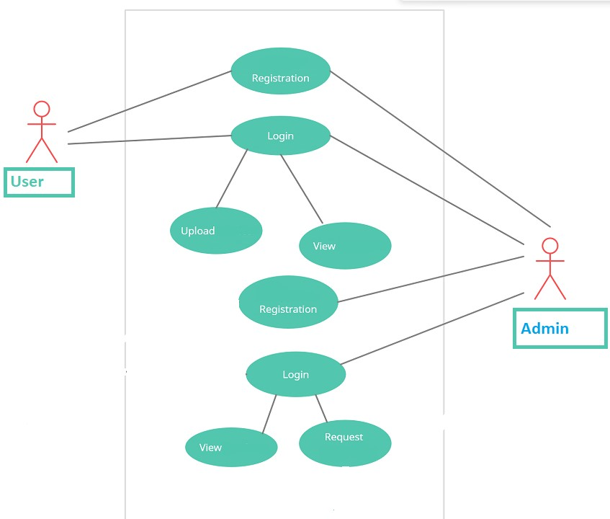

Brief Description | User Registration
Basic Flow | This use case describes how a client register in to the system  - The client has to register himself into the system.  - After the successful registration, client will get a success message.  - The following information is required during registration.  - Name  - Address  - Email  - Mobile Number
Alternate Flow | - The system will validate the information provided. If any invalid data is found, the input form will be redirected with error message.
Validation | - Name is required and minimum 3 characters and max 30 characters.  - Address can be Alphanumeric.  - City/State/Country should be selected from a drop-down.  - The Email should be valid.
Pre-Conditions | User should have network access and Browser with latest updates.
Post-Conditions | Success message should be shown.

Brief Description | Login
Basic Flow | This use case describes how a user log-in in to the system  - The user has to register himself into the system.  - After the successful login, user will be taken to the appropriate landing page.  - The following information is required to login.  - Username  - Password
Alternate Flow | - The system will validate the credentials provided. If credentials are invalid, login form will be redirected again with error message.
Validation | - Valid username  - Valid password
Pre-Conditions | User should have network access and Browser with latest updates.
Post-Conditions | Landing page has to be displayed.

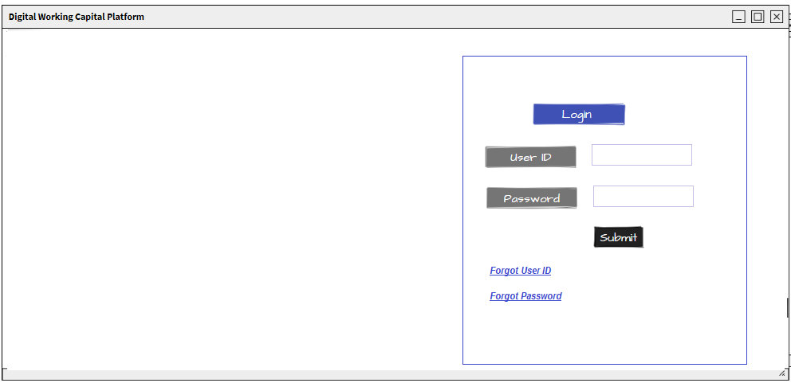

Brief Description | Add Center
Basic Flow | This use case describes how an admin added the center into the system.  - The admin has to login into the system.  - The following information is required during upload invoice.  - Center Name  - Address  - City  - State  - Pin Code
Alternate Flow | - The system will validate the information provided. If any invalid data is found, the input form will be redirected with error message.
Validation | - Center Name should be valid  - Address should be correct.  - Pin Code should be of numeric only.  - File size should not be greater than 1MB
Pre-Conditions | User should have already logged into the system.
Post-Conditions | Success message should be shown.

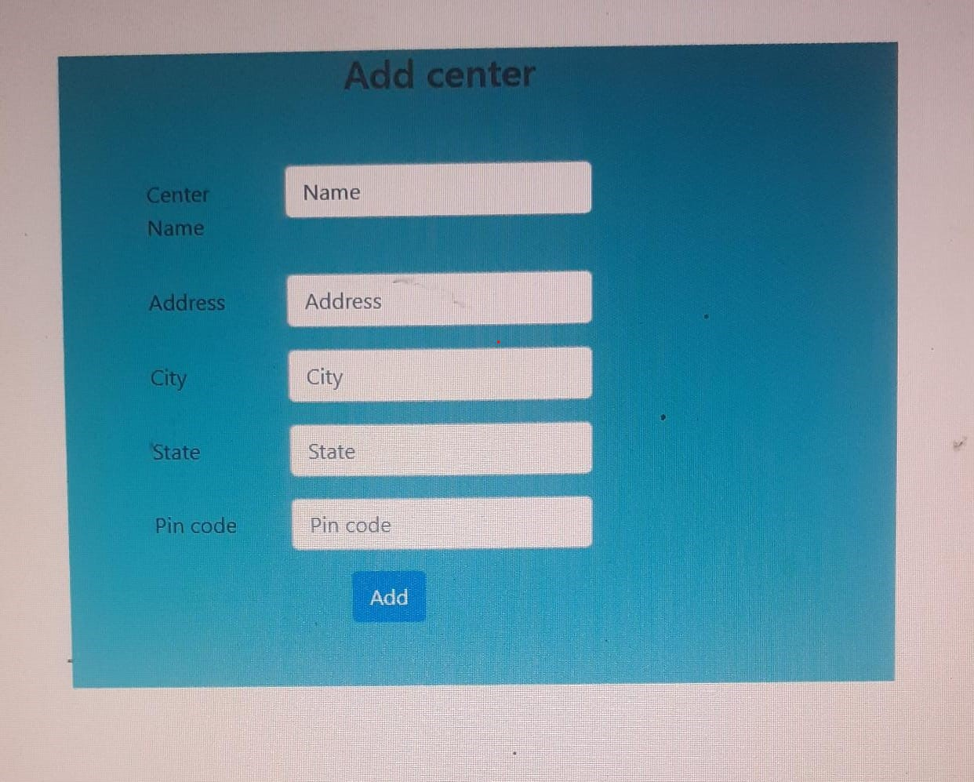

Brief Description | Add Cylinder (Admin)
Basic Flow | This use case describes how a Admin can add the cylinder.  - The admin has to login into the system.  - The following information has to be displayed.  - Cylinder Type  - Cylinder Center  - Weight  - Quantity  - Price per Cylinder
Alternate Flow | Not Applicable
Validation | Not Applicable
Pre-Conditions | User should have already logged into the system.
Post-Conditions | Not Applicable

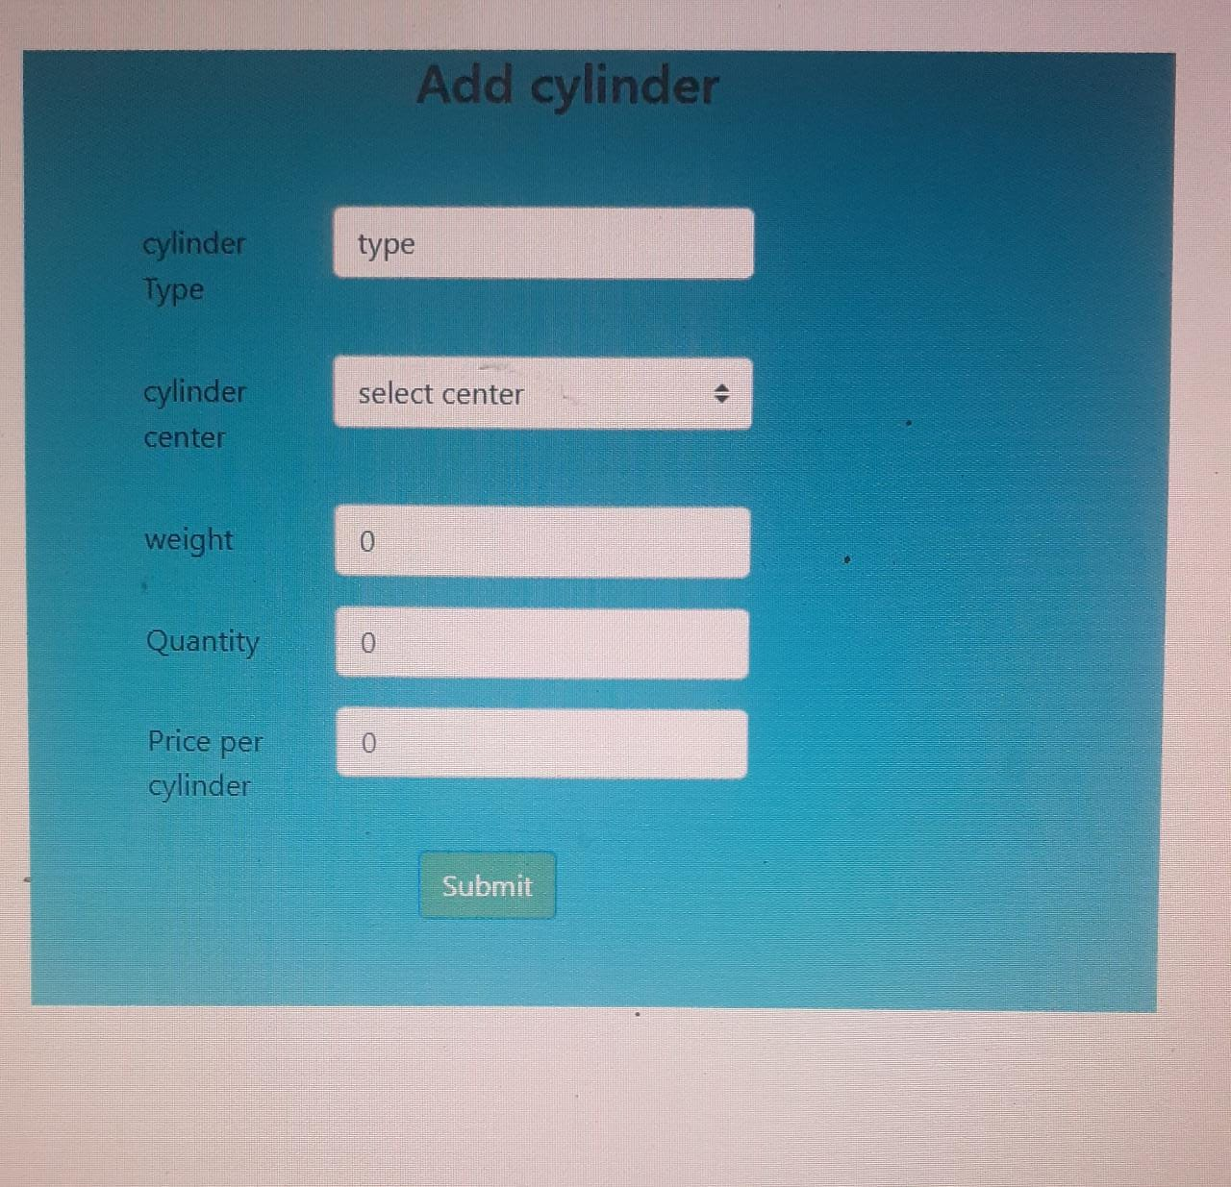

Architecture Diagram

Layer
Logical View
Technology/ Framework

UI Components

Presentation Layer
HTML/ CSS/ JavaScript/ AJAX/ Angular
Export (pdf)
Validations

Report

Java 1.8/ Spring MVC
Application/ Business Layer

Controllers

Service
REST Controllers

Entity/ Model Classes

Data Access Layer
Repository classes
Hibernate ORM

Oracle 11g Database

Resources

Presentation Layer:
This layer consists of all UI components.
- Export component: The plug-in is used to export the reports in pdf format. It helps to reduce the workload on the web/ application server.
- Validation component: All basic level data validations should be done at UI level.
- Report component: All reports to be generated to the user, will be processed and generated at the browser end.
- Resources: All HTML/CSS/ images, which are required for the page design.
Application Layer:
This layer comprises of all server and business classes.
- Configuration settings (XML or Class based) will define the application and server configuration.
- Spring Controllers defines the server classes, which are required to process the incoming http requests.
- Service classes are required to perform the required business services.
- REST Controllers to process the HTTP AJAX requests.
- Model classes are used the define the functions of the entities present in the system.
Data Layer:
Data layer is implemented through Hibernate ORM. It will contain the repository classes, which provides interface to the table.

Class Diagram

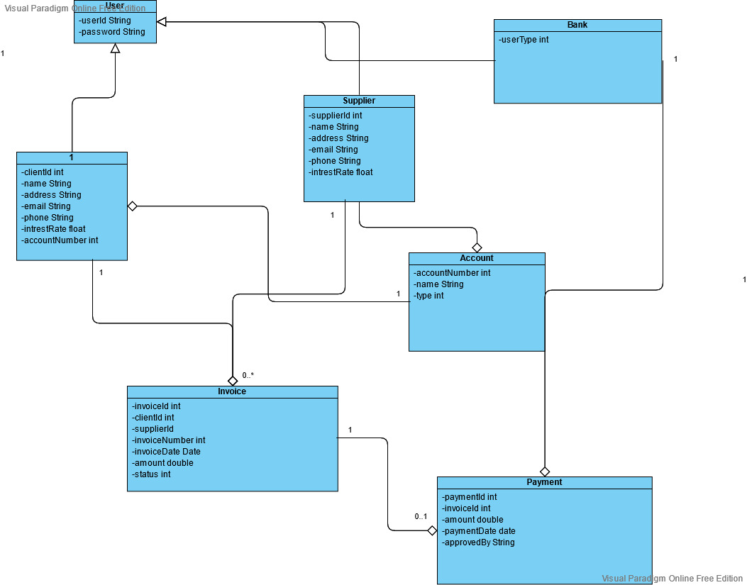

Sequence diagram




